**DIVER INFORMATION**

**Name:** [enter diver name]

**MMSI:** [enter mmsi]

**Station:** “[call-sign e.g. first name]”

**VHF CHANNELS**

**Distress/Hail – Channel 16**

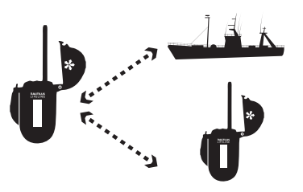Used for **distress calling** (using **MAYDAY** signal), and ***hailing the dive boat*** (or other divers carrying VHF radios). *Channel 16* should be monitored continuously if diver is missing.

**Chat – Channel 73**

Once hailed on Ch16, **diver will suggest** switch to *Channel 73* for exchange of messages (e.g. to radio position). Other channels will not be used due to limited function of the Nautilus device.

**Diver-to-Boat – *Ch16***

**About the Nautilus Lifeline Device**

This diver is carrying a Nautilus Lifeline ***VHF Radio & GPS*** with ***Digital Selective Calling (DSC)***. The device can only be used on the surface and has a best case range of **5 NM** (diver to boat), or **8 NM** (diver to coast station). At full charge it can broadcast a digital emergency call to all modern VHF radios for up to 24 hours.

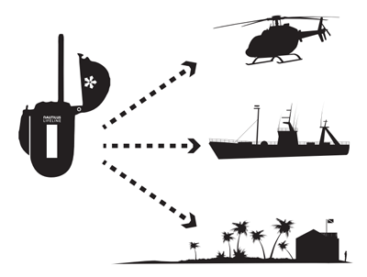**Modes of Operations**

**EMERGENCY DSC – *Ch70***

**YELLOW**

**The following colour coded Surface Marker Buoy (SMB) will be observed by this diver on all dives. Boat operator/surface support should assume worst case scenario and act accordingly.**

**Surface Marker Buoy (SMB) Protocols**

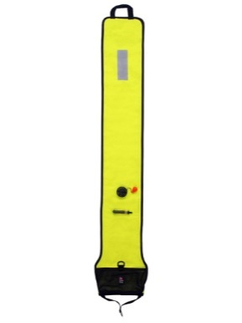Indicates an **underwater emergency** is currently in progress. Diver/s involved needs assistance from surface.

**Actions:**

1. **Track SMB;**
2. **Deploy emergency gas down SMB line;**
3. **Monitor surface for ascending diver**

**RED / ORANGE**

No emergency exists. **Diver is ok** and engaged in ascent/decompression procedures.

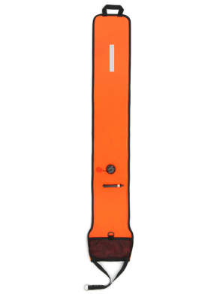**Actions:**

1. **Track SMB;**
2. **Wait for diver to   
   ascend to surface;**
3. **Monitor for yellow SMB.**